IE 251 Class Work #3 Oct 13

1. The following circuit operates if and only if there is a path of functional devices from left to right. The probability each device functions is as shown. What is the probability that the circuit operates?

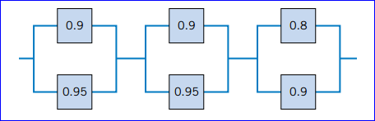

2. An inspector working for a manufacturing company has a 99% chance of correctly identifying defective items and a 0.5% chance of incorrectly classifying a good item as defective. The company has evidence that its line produces 0.9% of nonconforming items.
(a) What is the probability that an item selected for inspection is classified as defective?
(b) If an item selected at random is classi fied as nondefective, what is the probability that it is indeed good?

IE 251 Class Work #2 Oct 6

1. If the last digit of a weight measurement is equally likely to be any of the digits 0 through 9,

(a) What is the probability that the last digit is 0?

(b) What is the probability that the last digit is greater than or equal to 5?

2. A credit card contains 16 digits between 0 and 9. However, only 100 million numbers are valid. If a number is entered randomly, what is the probability that it is a valid number?

